First Grade-Math
January
Complete one activity each day
Day 1  Happy New Year! | Day 2  What time is on this clock? Explain how you know.  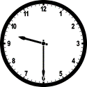 | Day 3  If you measured the length of your shoe using pennies, how many would you need?  Let’s try it and find out if you were correct! | Day 4  How many days are in this month? How many Wednesdays are in this month? | Day 5  What takes longer: watching a TV show or brushing your teeth? | Day 6  Do you brush your teeth before or after you come to school? Name something you do after school. | Day 7  Play Outer Space Chase and go to  www.firstinmath.com
Day 8  Play Outer Space Chase and go to  www.firstinmath.com | Day 9  Show the number of dimes you could trade for 50 pennies. | Day 10  Which would hold more water: a bathtub or a swimming pool? How do you know? | Day 11  Think about the milk carton from the lunchroom. Will it hold more or less than the milk carton in your refrigerator? How do you know? | Day 12  If I have to go to a meeting in a week, when will I be going? | Day 13  What month comes 2 months after January? What month comes 2 months before January? | Day14  Play Outer Space Chase and go to  www.firstinmath.com
Day 15  Play Outer Space Chase and go to  www.firstinmath.com | Day 16  NO SCHOOL  MLK Day  Which line is longer? How can you tell? | Day 17  Draw a picture of something that you would be doing at 8:30 p.m. | Day 18  Which cup would hold more? How do you know?  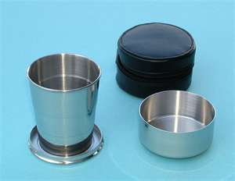 | Day 19  Tell a story about this seesaw. Use the words heavier and lighter.  | Day 20  Draw a picture of your family in order from lightest to heaviest. | Day 21  Play Outer Space Chase and go to  www.firstinmath.com
Day 22  Play Outer Space Chase and go to  www.firstinmath.com | Day 23  Do 20 jumping jacks. Did that take 1 minute or 1 hour? Explain your thinking. | Day 24  Would you use a bucket or a spoon to empty the bathtub? Why? | Day 25  Do you think that your teacher or you could pick up more coins? Why? | Day 26  Show 3 different ways to make 42. | Day 27  Would more marbles or dimes fit into a coffee cup? How do you know? | Day 28  Play Outer Space Chase and go to  www.firstinmath.com
Day 29  Play Outer Space Chase and go to  www.firstinmath.com | Day 30  Use a fork to measure the length of 4 different items in your house. Record you findings | Day 31  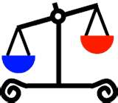  What are 2 objects that could be placed into this scale to make the picture true?

